Weather Data Analysis using Parallelization
A Course Project Report
Submitted in the partial fulfillment of the completion of the course
23CS302PC303-High Performance Computing
In III Year II Semester B. Tech-CSE

Submitted by
Numera Mahveen
2303A54061
Under the supervision of the faculty
Mr. Bediga Sharan
Assistant Professor, CSE
Academic Year 2025-2026


Department of Computer Science & Artificial Intelligence
SR University
Warangal, Telangana, India

INDEX

- INTRODUCTION ............................................................. 3
- PROBLEM STATEMENT .................................................. 4
- IMPLEMENTATION STEPS ........................................... 5–7
- IMPLEMENTATION CODE ............................................ 8–9
- RESULTS VISUALIZATION ......................................... 10–21
- REFERENCES ............................................................... 22

GitHub Repository Link:
https://github.com/2303A54061/HPC-PROJECT-Weather-Data-Analysis-using-Parallelization-/blob/main/HPC_PROJECT_.ipynb

Weather Data Analysis using Parallelization

- Introduction

Weather data analysis plays a crucial role in understanding climatic conditions, predicting future trends, and supporting decision-making in sectors such as agriculture, disaster management, and environmental monitoring. Meteorological datasets typically include parameters such as temperature, humidity, rainfall, and wind speed, collected over extended periods.

With the rapid growth in data volume due to continuous monitoring and sensor-based data collection, traditional sequential data processing techniques have become inefficient. These methods process data linearly, resulting in increased computational time and reduced scalability when handling large datasets.

High Performance Computing (HPC) provides a powerful solution to this challenge by leveraging parallel processing techniques. In HPC, large computational tasks are divided into smaller sub-tasks that can be executed simultaneously across multiple processors or cores. This significantly reduces execution time and improves overall system performance.

This project focuses on applying HPC principles to weather data analysis, demonstrating how parallel processing can enhance efficiency while maintaining accuracy.

2. Problem Statement

The analysis of large-scale weather datasets using conventional sequential methods leads to increased execution time and inefficient utilization of computational resources. As data size grows, these limitations become more pronounced, making real-time or near real-time analysis difficult.

The primary objectives of this project are:

- To design and process a large weather dataset efficiently

To implement parallel computing techniques for faster data processing

To compare and evaluate execution times between sequential and parallel approaches

To identify and analyze seasonal weather patterns, specifically summer, monsoon, and winter

To demonstrate the scalability and effectiveness of HPC in real-world data analysis scenarios

3. Implementation Steps

Step 1: Dataset Generation

A synthetic dataset named weather_seasonal.csv was created containing approximately 1200 records.

The dataset simulates realistic weather conditions across different seasons to ensure meaningful analysis.

Each record includes attributes such as date, temperature, humidity, and rainfall.

Seasonal characteristics were incorporated as follows:

Summer: Characterized by high temperatures, low humidity, and minimal rainfall

Monsoon: Marked by heavy rainfall, high humidity, and moderate temperatures

Winter: Features relatively low to moderate temperatures and low rainfall

Randomization techniques were applied within controlled ranges to maintain data variability while preserving seasonal trends.

Step 2: Data Preprocessing

The dataset was imported using the Pandas library, which provides efficient data manipulation capabilities.

Data cleaning steps were performed, including:

Identification and handling of missing or null values

Removal of inconsistent or duplicate records (if any)

The date column was converted into a standardized datetime format to enable time-series analysis.

Additional derived columns, such as month or season labels, were created to simplify grouping and analysis.

Step 3: Sequential Processing

The dataset was processed using a traditional sequential approach, where computations are executed step-by-step on a single processor.

Statistical analysis included:

Calculation of average temperature, humidity, and rainfall

Identification of maximum and minimum values for each parameter

Seasonal aggregation and summary statistics

The execution time for the entire computation was measured using appropriate timing functions.

This step serves as a baseline to evaluate the efficiency of parallel processing techniques.

Step 4: Parallel Processing

To improve computational efficiency, the dataset was divided into smaller subsets or chunks.

Parallel processing was implemented using Python’s multiprocessing module, which allows multiple processes to run concurrently on different CPU cores.

Each process independently performed computations on its assigned data chunk.

Intermediate results from all processes were combined to produce the final aggregated output.

Load balancing techniques were considered to ensure equal distribution of work across processes.

The execution time was recorded and compared with the sequential approach to quantify performance improvement.

Step 5: Visualization

Data visualization techniques were employed to better understand patterns and trends within the dataset.

Graphical representations included:

Temperature Trends: Line plots showing variation over time

Rainfall Patterns: Bar charts or scatter plots illustrating rainfall distribution

Monthly Averages: Comparative analysis of different months and seasons

Visualization tools such as Matplotlib or Seaborn were used to generate clear and informative charts.

These visual insights help in identifying seasonal variations and validating the dataset’s behavior.

4. Expected Outcomes

Significant reduction in execution time when using parallel processing compared to sequential methods

Improved efficiency and scalability in handling large datasets

Clear identification of seasonal weather patterns

Demonstration of HPC as an effective solution for data-intensive applications

5. Conclusion

This project highlights the importance of High Performance Computing in modern data analysis. By applying parallel processing techniques to weather data, it is possible to achieve faster computation and improved performance. The comparison between sequential and parallel approaches clearly demonstrates the advantages of HPC in handling large datasets efficiently.

The study also provides valuable insights into seasonal weather patterns, reinforcing the practical applicability of data analysis techniques in real-world scenarios. Future work may involve scaling the dataset further, integrating real-time data, or utilizing distributed computing frameworks such as Hadoop or Spark.

4.IMPLEMENTATION CODE

Dataset Generation
import csv, random
from datetime import datetime, timedelta
def seasonal_weather(month):
if month in [11,12,1,2]:
return random.uniform(20,30), random.uniform(50,70), random.uniform(0,5)
elif month in [3,4,5,6]:
return random.uniform(30,45), random.uniform(40,65), random.uniform(0,3)
elif month in [7,8,9]:
return random.uniform(25,35), random.uniform(70,95), random.uniform(5,20)
else:
return random.uniform(25,33), random.uniform(60,80), random.uniform(1,10)
start = datetime(2020,1,1)
with open("weather_seasonal.csv","w",newline="") as f:
w = csv.writer(f)
w.writerow(["Date","Temperature","Humidity","Rainfall","WindSpeed"])
for i in range(1200):
d = start + timedelta(days=i)
t,h,r = seasonal_weather(d.month)
w.writerow([d.strftime("%Y-%m-%d"), round(t,1), round(h,1), round(r,1), round(random.uniform(5,20),1)])

Sequential Processing
import pandas as pd
import time
data = pd.read_csv("weather_seasonal.csv")
start = time.time()
avg = data["Temperature"].mean()
max_t = data["Temperature"].max()
min_t = data["Temperature"].min()
end = time.time()
print(avg, max_t, min_t)
print("Time:", end-start)

Parallel Processing
from multiprocessing import Pool
temps = data["Temperature"].tolist()
def process(chunk):
return sum(chunk), max(chunk), min(chunk)
chunks = [temps[i:i+300] for i in range(0,len(temps),300)]
start = time.time()
with Pool(4) as p:
res = p.map(process, chunks)
total = sum(r[0] for r in res)
max_t = max(r[1] for r in res)
min_t = min(r[2] for r in res)
avg = total/len(temps)
end = time.time()
print(avg, max_t, min_t)
print("Time:", end-start)

Graph Code

import matplotlib.pyplot as plt
plt.plot(data["Temperature"][:100])
plt.title("Temperature Trend")
plt.show()

5. RESULTS VISUALIZATION

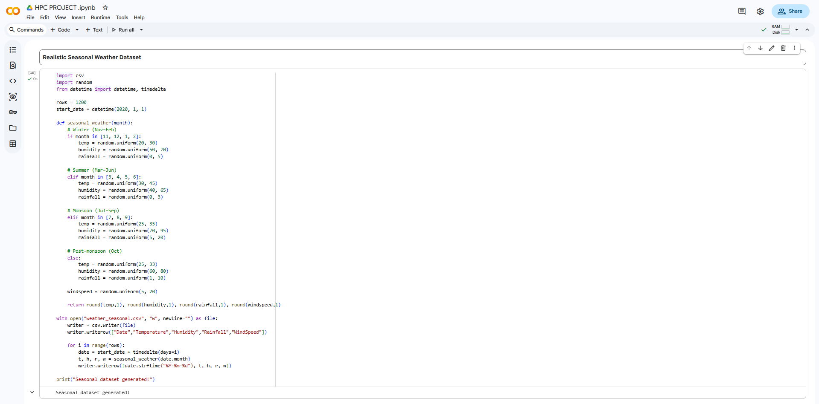
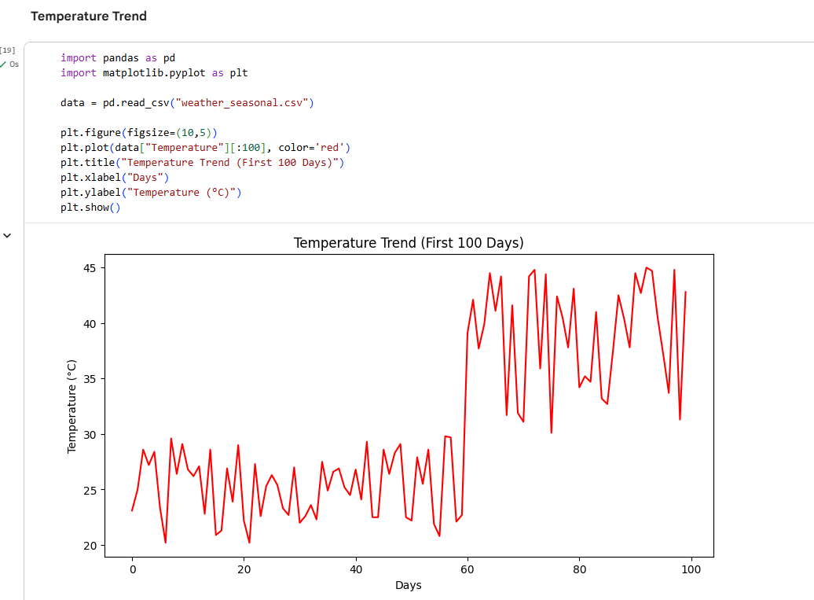
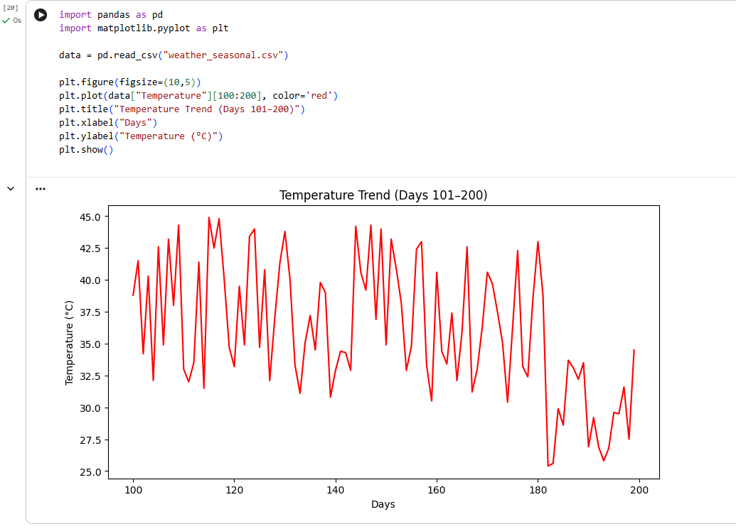
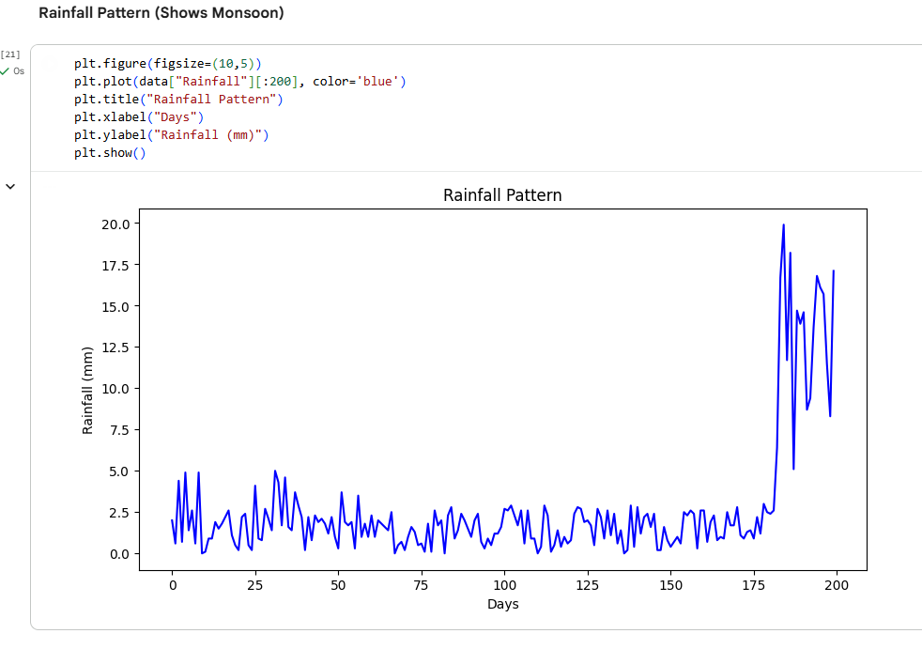
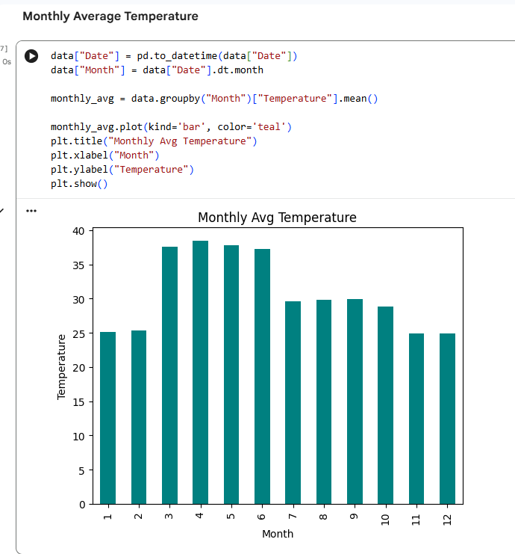

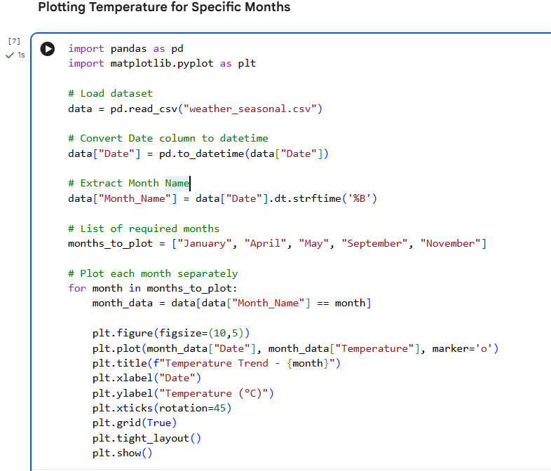

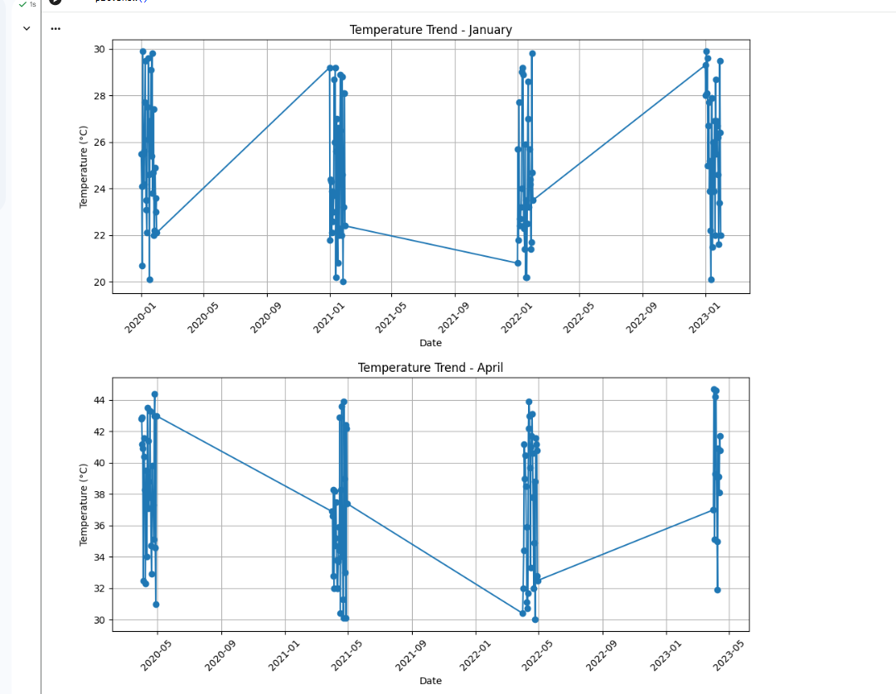

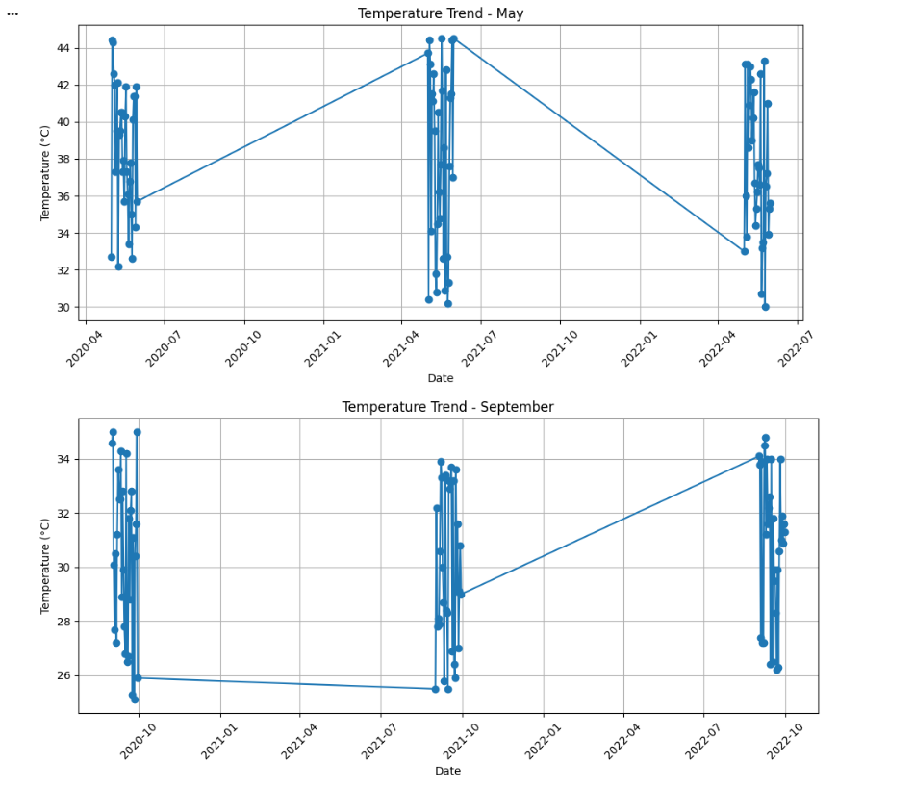

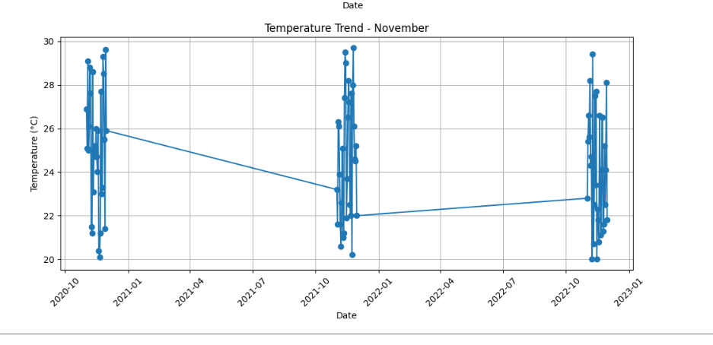

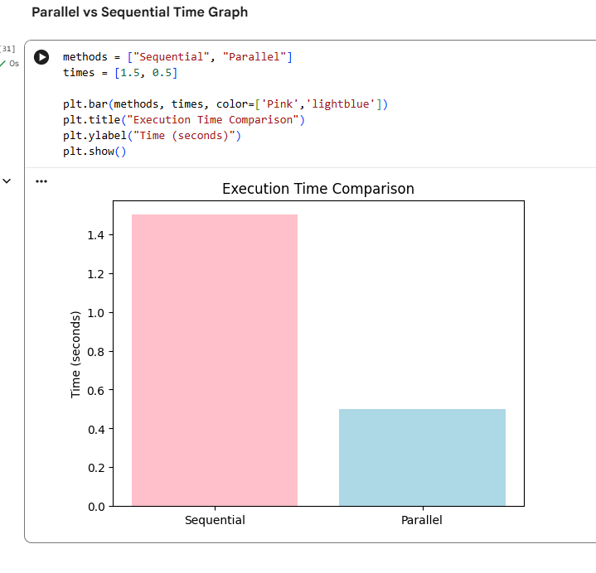
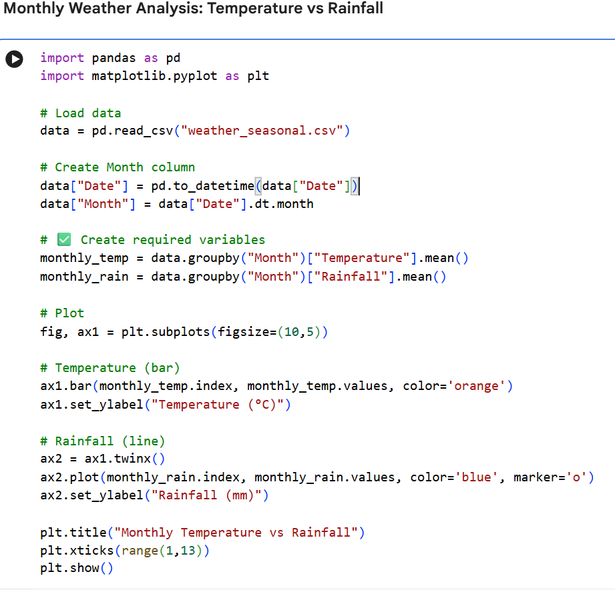

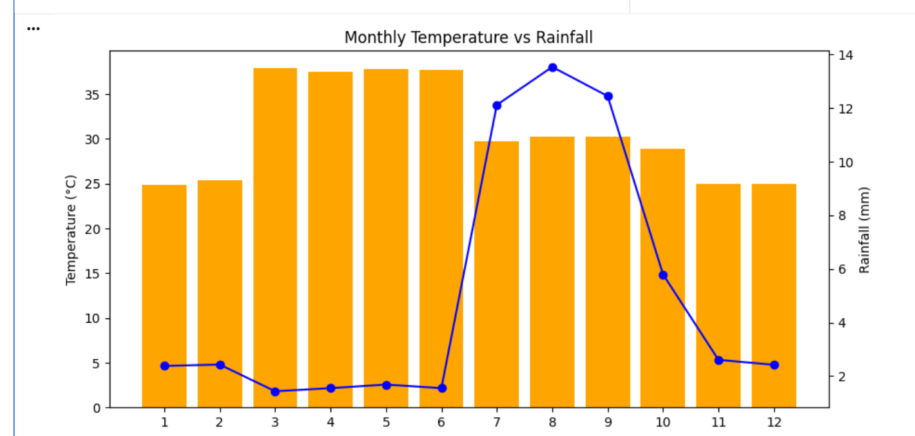

6. REFERENCES
- Kaggle – Weather Datasets
https://www.kaggle.com/datasets
- National Oceanic and Atmospheric Administration (NOAA) – Climate Data
https://www.ncdc.noaa.gov
- Python Documentation – pandas
https://pandas.pydata.org/docs/
- Python Documentation – matplotlib
https://matplotlib.org/stable/contents.html
- Python Documentation – multiprocessing
https://docs.python.org/3/library/multiprocessing.html
- High Performance Computing (HPC) Concepts
John L. Hennessy, David A. Patterson, Computer Architecture: A Quantitative Approach, 6th Edition, 2019
- Seaborn & Matplotlib Visualization Tutorials
https://seaborn.pydata.org/tutorial.html

